**CENWP-OD-B29 July 2024**

**MEMORANDUM FOR THE RECORD**

**SUBJECT: 24BON036 MFR AFF Valve 15 Pacific Lamprey Mortalities**

On the morning of 29 July, Columbia River Inter-Tribal Fish Commission (CRITFC) Biologists notified Bonneville Project Biologists of two lamprey mortalities found on the valve 15 trash rack in the Adult Fish Facility (AFF). The fish were scanned for PIT tags, inspected, and returned to the river.

1. Species – Pacific Lamprey (*Entosphenus tridentatus)*
2. Origin – Unknown
3. Length – In descending order in the picture: 66 cm, 62 cm
4. Marks and tags – None
5. Marks and Injuries found on carcass – None
6. Cause and Time of Death – Unknown
7. Future and Preventative Measures – None

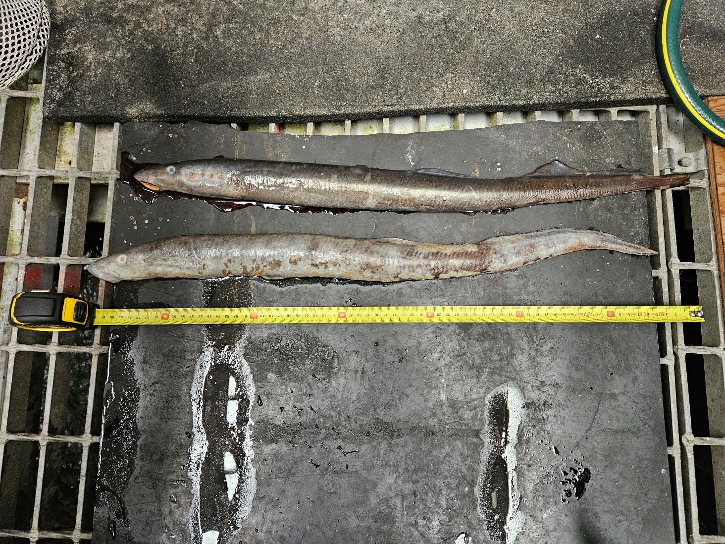

Sincerely,

Project Fisheries